ONEWAY CS BY HAD
/STATISTICS DESCRIPTIVES HOMOGENEITY WELCH
/PLOT MEANS
/MISSING ANALYSIS.

Oneway

Notes
Output Created |  | 05-May-2019 23:33:17
Comments
Input | Active Dataset | DataSet0
Input | Filter | <none>
Input | Weight | <none>
Input | Split File | <none>
Input | N of Rows in Working Data File | 30
Missing Value Handling | Definition of Missing | User-defined missing values are treated as missing.
Missing Value Handling | Cases Used | Statistics for each analysis are based on cases with no missing data for any variable in the analysis.
Syntax |  | ONEWAY CS BY HAD  /STATISTICS DESCRIPTIVES HOMOGENEITY WELCH  /PLOT MEANS  /MISSING ANALYSIS.
Resources | Processor Time | 00 00:00:00.156
Resources | Elapsed Time | 00 00:00:00.163

[DataSet0]

Descriptives
 | N | Mean | Std. Deviation | Std. Error
1-4 hours per day | 10 | 38.3000 | 2.75076 | .86987
4-8 hours per day | 6 | 40.0000 | .00000 | .00000
Less than an hour a day | 9 | 36.5556 | 4.09607 | 1.36536
More than 8 hours per day | 5 | 40.0000 | .00000 | .00000
Total | 30 | 38.4000 | 3.00115 | .54793

Descriptives
 | 95% Confidence Interval for Mean |  | Minimum | Maximum
 | Lower Bound | Upper Bound | Minimum | Maximum
1-4 hours per day | 36.3322 | 40.2678 | 34.00 | 40.00
4-8 hours per day | 40.0000 | 40.0000 | 40.00 | 40.00
Less than an hour a day | 33.4070 | 39.7041 | 28.00 | 40.00
More than 8 hours per day | 40.0000 | 40.0000 | 40.00 | 40.00
Total | 37.2794 | 39.5206 | 28.00 | 40.00

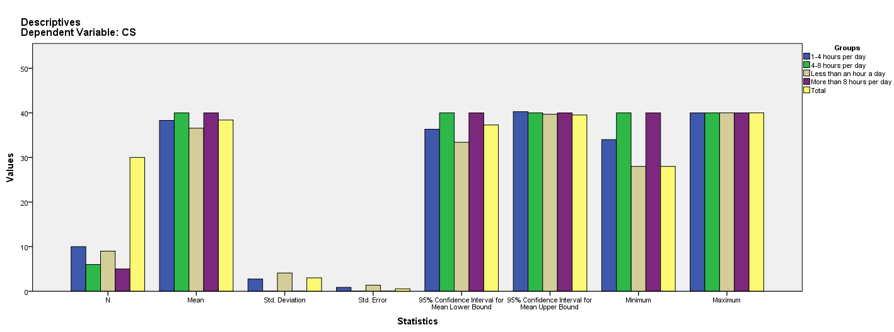

Test of Homogeneity of Variances
CS
Levene Statistic | df1 | df2 | Sig.
7.506 | 3 | 26 | .001

ANOVA
CS
 | Sum of Squares | df | Mean Square | F | Sig.
Between Groups | 58.878 | 3 | 19.626 | 2.522 | .080
Within Groups | 202.322 | 26 | 7.782
Total | 261.200 | 29

Robust Tests of Equality of Means^{b}
CS
 | Statisticª | df1 | df2 | Sig.
Welch | . | . | . | .
a. Asymptotically F distributed.
b. Robust tests of equality of means cannot be performed for CS because at least one group has 0 variance.

Means Plots

